C.Cooper: Condensed Birkman

General Interest
Typical activities include:
• planning
• dealing with abstraction
• thinking of new approaches
• innovating
• working with ideas

Likes to:
• innovate or create
• plan how to do things
• consider the future
• create new approaches
• look at things theoretically

General Style
Typically:
• insightful
• selectively sociable
• thoughtful
• reflective
• optimistic
Generally:
• insightful
• optimistic
• thoughtful
• selectively sociable
• reflective

General Stressors
Typical behaviors:
• dominating
• self-protective
• easily distracted
• disorganized
• driven
• strong-willed
• high expectations

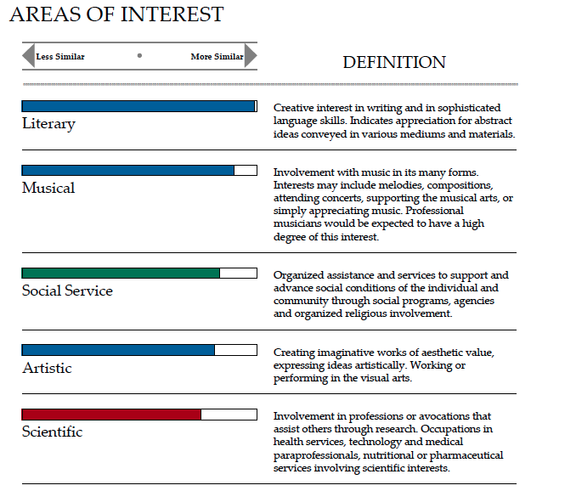
General Strengths
• unevasive
• matter-of-fact
• frank and open
• direct and straightforward
• independent by nature
• able to be and work alone
• withstands group pressure
• balances structure and flexibility
• combines action and planning
• self-starting, but adaptable
• authoritative, yet pleasant
• open to discussion
• self-directive

General Needs
• others to be frank and forthright

POSSIBLE STRESS REACTIONS WHEN NEEDS ARE NOT MET:
• too much independence
• withdrawal
• impatience with group dynamics
• resistance to routine
• weakened follow-through
• neglect of order and system
• discouragement
• loss of energy
• experiencing tedium • annoyance at delays
• problems with self-discipline
• inability to concentrate
• unnecessary worry about decisions
• impulsivity

More than most people, you tend to focus on your personal shortcomings rather than your strengths. As a result, you
are able to take a great deal of pride in your accomplishments, and respond well to difficult or demanding tasks and goals.

